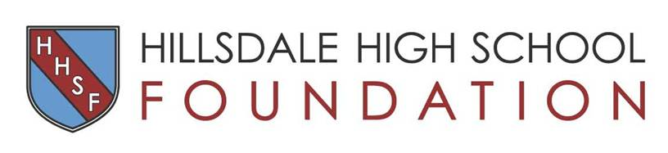

Corporate Partnership to Promote your Business
Proceeds benefit Hillsdale High School's Small Learning Communities
When you promote your business with Hillsdale you reach a targeted community of 5,000+: 1,600 students, 3,000 parents, alumni and other community members who attend our events. It shows you value the Hillsdale education and its students.
 | Bishop Sponsor | Knight Sponsor | Armor Sponsor | Shield Sponsor | Sword Sponsor
Advertising Medium/ Benefit | $10,000 | $5,000 | $2,500 | $1,250 | $850
Web Sites- corporate logo placed on - HHS Foundation, Athletics, Dance, Drama, Music, & PTSO Web Sites | Largest/  Highest | Large | Medium | Small | Contributor's Listing
Sponsor Banner - at Athletic Fields & Visual Performing Arts Events, PTSO & HHS Foundation events including Knight Out Event, Hall of Fame, Olde Knights Luncheon  LISTED BY SPONSOR LEVEL | x | x | x | x | x
Advertisement in all Booster Event Programs: (Drama, Dance, Music (Concerts), HHS Foundation | Full page | Full page | 1/2 pg | 1/4 pg | Biz Card
Complimentary Tickets to Athletics Events or Visual/ Performing Arts Events (Dance, Drama, & Music) | 8 | 8 | 6 | 4 | 2
Advertisement in the student newspaper "The Scroll" | Largest/Highest | Large | Medium | Small | Contributor's Listing
PTSO E-Bulletin with weekly distribution to entire Hillsdale community. Live links to all Corporate Partners (listed by level) | x | x | x | x | x

Make checks payable to: Hillsdale High School Foundation, 63 Bovet Road, Suite 218, San Mateo, CA 94402

Please include a business card with your reply. We will contact you to arrange for a copy of your business logo for inclusion in promotional materials. For more information about the Hillsdale High School Foundation, please visit www.HillsdaleHSFoundation.org.
Questions? Contact Jennifer Russell at execdirector@hillsdalehsfoundation.org

The Hillsdale High School Foundation is an IRS 501(c)(3) tax exempt, non-profit organization. Tax ID #87-0800728. Donations to the Hillsdale High School Foundation are fully tax-deductible to the extent allowed.

