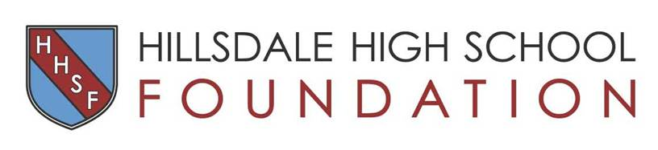

Business/Corporate Partnership
Commitment Form

Proceeds benefit Hillsdale High School's Small Learning Communities and all Booster Groups

NAME OF BUSINESS ______________________________________________
Please print your business name exactly as you would like it to appear in promotional publications and acknowledgements.

CONTACT NAME_____________________________________________________________
ADDRESS____________________________________________________________________
PHONE___________________________EMAIL_____________________________________
SPONSOR LEVEL: : Bishop $10,000 ___ Knight $5,000 ___ Armor $2,500___ Shield $1,250___ Sword $850___

* Please include a business card with your reply and keep a copy of this form for your records. We will contact you to arrange for a copy of your business logo for inclusion in promotional materials.

Please make your check payable to the Hillsdale High School Foundation and mail to:
Hillsdale High School Foundation, 63 Bovet Road, Suite 218, San Mateo, CA 94402
Or contact me to pay by credit card.
Thank you for your support of Hillsdale High School. Your contribution will help to ensure that our school's unique learning environment will continue, and our students will thrive and succeed.

For more information about the Hillsdale High School Foundation, please visit www.HillsdaleHSFoundation.org.
Contact Jennifer Russell at execdirector@hillsdalehsfoundation.org if you have any questions.

The Hillsdale High School Foundation is an approved IRS 501(c)(3) tax exempt, non-profit organization. Federal Tax ID no.87-0800728
Donations to the Hillsdale High School Foundation are fully tax deductible to the extent allowed.

